REQUIRMENTS ANALYSIS

By: Davin Heilich

**Introduction:**

This document is to give a requirements analysis of my final project in software engineering based on the problem of keeping a status on open source project to know if they will be around long and working well in the future of their lifespan with this we are basing this project around using augur as it is a metric system for open source projects like these that the problem arises around.

**Software Product Overview:**

This section provides an overview of augur and how the system should perform for all users perspectives.

**System Use:**

* to provide users with a greater knowledge of open source projects
* display metrics to show the health of projects
* to allow metrics to be formed from data gathered allowing better visualizations

**Actor Survey:**

**Admin:**

Admin would be responsible for keeping augur up to date and continuing to add new metrics to the system allowing the better judgement of open source projects

**Users:**

Users would be the ones using the system and giving feedback on how they think the metrics are doing on grading the open source projects health as the purpose of augur is this in the end.

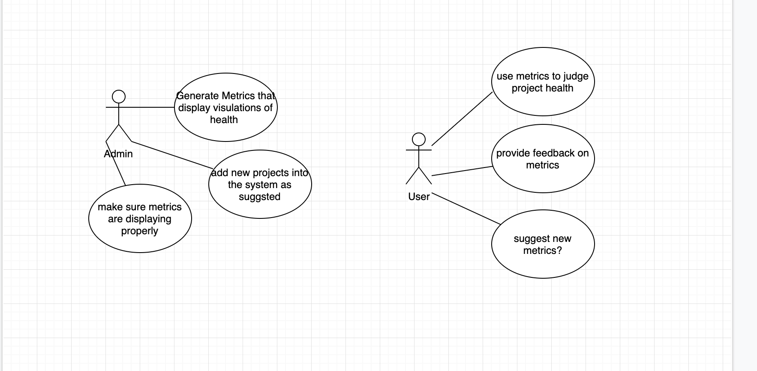

**Functional System Requirements:**

The system will be easy to understand and use for users with little prior knowledge

* the system will permit users to request new metrics easily and check if progress has been made on them
* the system will give an error if a metric has not yet been created and alert the user what is wrong

**Non-Functional Requirements:**

* The system will be display metrics in under 100ms of requesting
* The system will provide the functions of uc2 by having an easy to use form and or ticket system where you can create a ticket and then check your ticket number to see the progress on that metric or if an admin has responded to the ticket
* System will display when an endpoint may be broken as it is being worked on

**Design Constraints:**

**-**  the system must be consistent throughout example (all endpoints of the api must have the same format of use to allow users easy use)

**-** system will run on all web browsers

**-** system should look the same on all platforms of browsers

**-** ssl should be enabled on the web application

**-** proper documentation should be given on each project that data is given about linking to the projects so that you can learn more about them

**Purchased Components:**

* A server to host the site on and allow users to access the service 24/7

**User Interface:**

The user interface should allow users to choose or search what project that they would like to view the metrics of then after they have selected this it should allow them to select what sort of metric they want to see once this has been selected it should navigate you to a page with some sort of visualization of the metric and break it down to the user as this data isn’t always easy to understand or make meaning of.